DLD-1 | Caco2
23.06.2026 green team: Line, Lars, Andreas
DLD1
Experiment 1: NaBu dose response
23.06.2026 green team: Line, Lars, Andreas:

Two 24-well plate.
Prepare dilutions of Resv according to the matrix below.
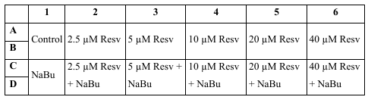
NaBu stock: 1 M, need 1mM -> x1000 dilution
Make an intermediate stock of ResV 100 mM --> 1 mM
10 ul 100 mM ResV + 990 uL DMSO

Now use the 1mM ResV stock.

Treat both 24 well plate: Replace the old medium with 1 ml of the ResV and NaBu containing medium and incubate 48 hours at 37 C

Make 3 stocks:
A: 12 ml McCoy media + 9,6 ul ResV (80 uM Resv)
B: 40 ml McCoy media + 40 ul NaBu (2mM NaBu)
C: 30 ml McCOoy media + 2 ul DMSO + 60 ul PBS

23.06.2026 green team: Line, Lars, Andreas  DLD-1  Experiment 2a: cell cycle  Treat with PBSw, 20 uM Resv and 10 mM NaBu  23-06-2026 green team: Line, Lars, Andreas  DLD-1: McCoy medium  Experiment 2A:  Need PBSw, 20 µM Resv and 5 mM NaBu  75 µl PBS + 3µl DMSO in 15 ml media  75 µl PBS + 3 µl Resveratrol in 15 ml media  Use 75 µl NaBu 3 µl DMSO in 15 ml media | 23.06.2026 green team: Line Lars Andreas  CaCo-2
23.06.2026 green team: Line, Lars, Andreas
DLD-1 and Caco2:
Experiment 2b:
Hoechst 33342 / Alamar Blue 96 well assays

Use the concentrations of NaBu and Resv as indicated in the diagram below. Add a volume of 200 µL for treatments.

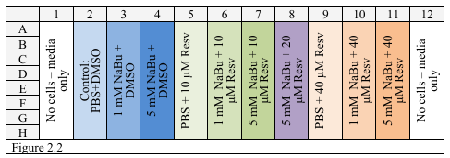

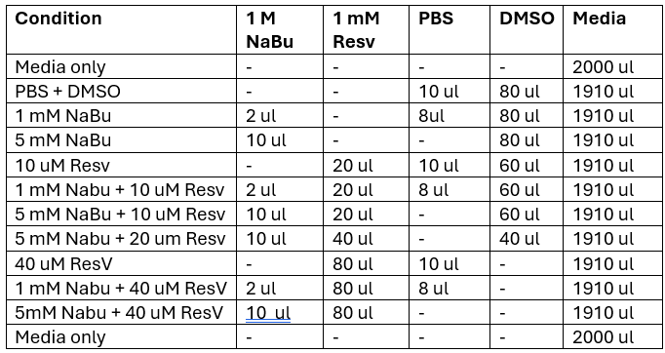

4 stock opløsning:
ResV
2mM Nabu med
PBS tilsvarende NaBu
DMSO tilsvarende resviratrol

23.06.2026 green team: Line, Lars, AndreasDLD-1:  Experiment 3:  Transfection with linear polyethyleneimine (PEI) and plasmids  - One hour prior to transfection mix the 250 µl DNA solution with 250 µl 2 µM PEI for each transfection condition.  Transfection mix  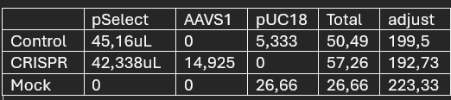  - Vortex briefly and let the reaction stand to form precipitates at room temperature  - Remove media of cells seeded in the 6 well plate and add 4 mL fresh supplemented DMEM media to each well.  - Add in small droplets, 245 µl of DNA / PEI mixture to the cells in each well. Avoid touching plastic surfaces. (PEI precipitates to the wells remember to mix it by pipetting up and down before taking out.)  - Incubate  - Measure luciferase activity on transfected Caco-2 cells (Similar to week 1) | 23.06.2026 green team: Line, Lars, Andreas Caco2:  Experiment 3:  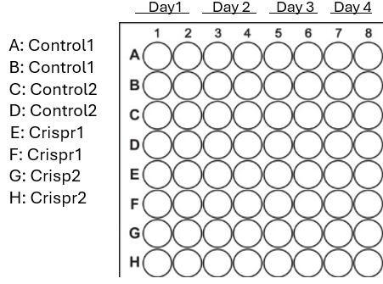
23.06.2026 green team: Line, Lars, Andreas
CaCo-2
Experiment 4:
Fluorescent imaging and staining:

Seal the edge of the cover slip with nail polish. Let the samples dry in petri dishes covered with tinfoil and store them in the refrigerator.

Fluorescence Microscopy with Ole!
Magnification: Use the 40x and perhaps the 60x objectives (needs oil)

Fluorescence filters (Leica DM IRB):
a. DAPI filter: Excitation: BP 340-380; Emission: LP 425,
b. Rhodamine filter: Excitation: BP 515-560; Emission: LP 590

Fading. Be aware that especially rhodamine fades quickly. Therefore, expose the areas of interest as short time as possible to fluorescent light, before acquiring images.

Identify the cells with phase contrast. Identify cells which are placed individually. Find the relevant focus. Switch to the fluorescence and take pictures. It is possible to take several pictures at the same position, but you might have to increase the exposure time (start with 15 ms, aperture 1).

Acquire the image of the DAPI staining at the exact same position (i.e. do NOT move the slide!).

